🏦 Parallex Bank API Policies Standards & Criteria
All staff, users and third parties granted access to the Bank’s information assets shall comply with the requirements in this document.

    - All APIs shall have an approved Business Requirement Documentation.
    - All APIs must have an owner. The API Owner should ideally also own the underlying service or data source or at least have an approving authority.
    - All API source code shall be stored in a central repository with tracking mechanism for authentication, authorization and accounting.
    - APIs shall be developed using Bank approved tools and methodologies.
    - API names shall follow an approved naming convention.
    - APIs shall be categorized in terms of consumers (internal or external) and criticality of the information being transmitted.
    - APIs can only be developed by the dedicated API Development Team, who have members trained on the Bank’s secure API development methodology/approach and have been trained as appropriate by the Team Lead.
    - All APIs shall undergo the relevant governance processes before being published:
      - Quality Assurance Management
      - Change Management
      - Security Certification
      - Configuration Management
      - Asset Management.
      - Release and Deployment
    - The API management platform shall have the functionality to meter and monitor usage and provide reports on same.
    - The API management platform shall have versioning capabilities.
    - Appropriate signoffs must be obtained from Chief Information Security Officer and Chief Information Officer before an API can be exposed to the public, either via the Bank’s sandbox or directly to the API consumer.
    - No APIs with capability to debit accounts shall be exposed to any 3rd party without the appropriate sign-off.
    - API usage shall be monitored, measured and reported.
    - API Modifications, Deletes and Adds shall follow the relevant governance processes. This also entails strict adherence to section 6.2
    - API retirement shall follow the relevant governance processes
    - The API owner shall approve the API retirement.
    - Adequate lead time shall be provided for API consumers to discontinue requests to the API scheduled for retirement.
    - API consumers shall be registered with the Bank as partners.
    - API consumers shall be required to provide details, including but not limited to the following:
      - Company name
      - Corporate Affairs Commission Certificate
      - Corporate Address
      - Contact phone
      - Email address
      - Product name and description
    - Background checks shall be carried out to verify submitted information
    - Well-commented agreement and indemnity covering the Bank shall be in place
    - All API parameters to be shared shall be clearly stated at the initiation stage.
    - Access to API shall be based on need to know and least access principles.
    - Documented approvals shall be required before a third-party is granted access to a requested API following the relevant processes.

🏦 Parallex Bank Azure DevOps Practice Standards
- Branching structure
✔️ Good Example
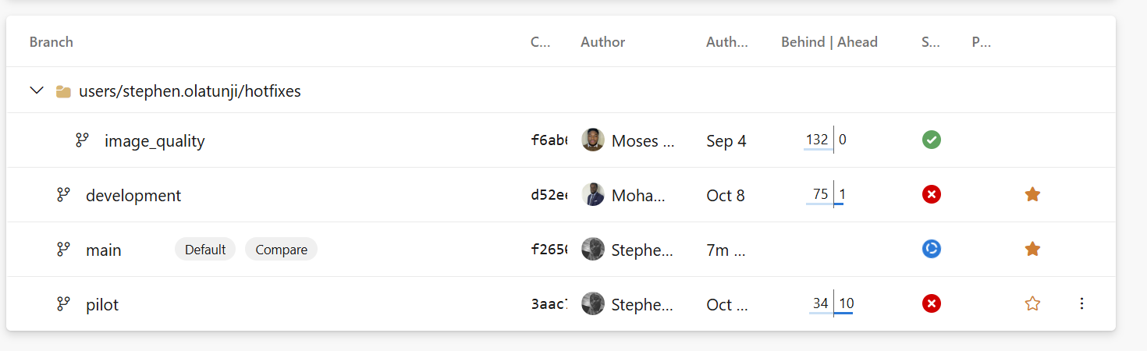
users/{firstname.lastname}/features/{FEATURE_NAME}
users/{firstname.lastname}/hotfixes/{HOT_FIX_NAME}
- Pull request format
- When sending pull requests to main or pilot, a developer is expected to create two PRs. 1 to pilot or main branch, & the other to development branch.
- When creating a new branch, always create the branch from main branch.
- A branch name must be in lower case.
- Every branch created must have a build pipeline configured.
✔️ Good Example
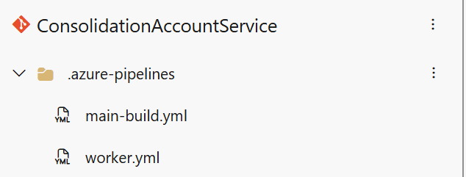

🏦 Parallex Bank Coding Standards & Principles
1️⃣ Naming Conventions
✅ Rule
- Classes / Interfaces → PascalCase
✔️ Good Example
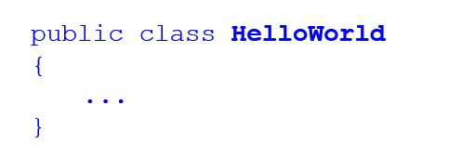
- Methods → PascalCase
✔️ Good Example
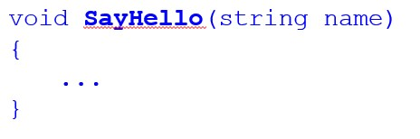
- Variables / Fields / Parameters → camelCase
✔️ Good Example
- Constants → UPPER_SNAKE_CASE
✔️ Good Example
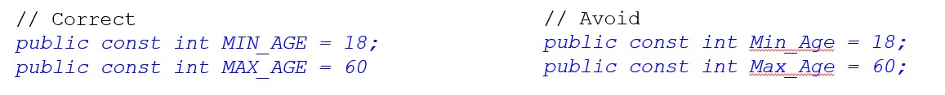
- Private fields → _camelCase
✔️ Good Example
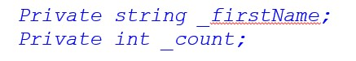
- Async methods → End with Async
- Interfaces → Prefix with I
✔️ Good Example
public interface IAccountService
{
Task<BalanceResult> GetAccountBalanceAsync(Guid accountId);
}
public class AccountService : IAccountService
{
private readonly IAccountRepository _accountRepository;
public async Task<BalanceResult> GetAccountBalanceAsync(Guid accountId)
{
var account = await _accountRepository.GetByIdAsync(accountId);
return new BalanceResult(account.Id, account.Balance);
}
}
❌ Bad Example
public interface accountservice
{
Task getbalance(Guid ID);
}
public class account_service
{
private IAccountRepository AccountRepo;
public async Task getbalance(Guid ID)
{
var acct = await AccountRepo.GetAccount(ID);
}
}

2️⃣ File and Project Organization
✅ Rule
- One class per file.
- File name matches class name.
- Group logically by feature, not layer (use vertical slicing).
✔️ Good Example
/Features/Accounts/AccountService.cs
/Features/Accounts/AccountController.cs
❌ Bad Example
/Services/AllServices.cs
/Utils/MiscClasses.cs

3️⃣ Method Design & Readability
✅ Rule
- Methods should be small and do one thing.
- Keep method length ≤ 30 lines.
- Avoid long parameter lists (use DTOs).
✔️ Good Example
public async Task TransferFundsAsync(TransferRequest request)
{
ValidateRequest(request);
await _transactionService.InitiateTransferAsync(request);
}
❌ Bad Example
public async Task Transfer(Guid src, Guid dest, decimal amt, string curr, bool intrabank, bool notify)
{
// lots of logic in one method
}

4️⃣ Secure Coding Practices
✅ Rule
- Never concatenate SQL or user inputs → use parameterized queries.
- Always validate user input.
- Sanitize logs — no sensitive data.
- Use SecureString or data masking for secrets.
- Protect configuration via Azure Key Vault or AWS Secrets Manager.
✔️ Good Example
using (var cmd = new SqlCommand("SELECT * FROM Accounts WHERE AccountId = @id", conn))
{
cmd.Parameters.AddWithValue("@id", accountId);
using var reader = await cmd.ExecuteReaderAsync();
}
❌ Bad Example
var query = "SELECT * FROM Accounts WHERE AccountId = '" + accountId + "'";
using var cmd = new SqlCommand(query, conn);

5️⃣ Exception Handling & Logging
✅ Rule
- Use try–catch only where you can handle errors meaningfully.
- Log exceptions with context, but not sensitive data.
- Avoid empty catch blocks.
- Throw domain-specific exceptions when needed.
✔️ Good Example
try
{
await _paymentProcessor.ProcessAsync(request);
}
catch (PaymentFailedException ex)
{
_logger.LogWarning(ex, "Payment failed for {TransactionId}", request.TransactionId);
throw;
}
❌ Bad Example
try
{
ProcessPayment(request);
}
catch (Exception)
{
// ignore
}

6️⃣ Asynchronous Programming
✅ Rule
- Always await async calls.
- Don’t block async with .Result or .Wait().
- Use ConfigureAwait(false) in libraries.
✔️ Good Example
var result = await _paymentGateway.AuthorizeAsync(card, amount);
return result;
❌ Bad Example
var result = _paymentGateway.AuthorizeAsync(card, amount).Result; // Deadlock risk

7️⃣ Dependency Injection & SOLID Principles
✅ Rule
- Depend on interfaces, not concrete types.
- Use built-in IServiceCollection or IoC containers.
- Avoid new inside business logic.
✔️ Good Example
public class TransferHandler
{
private readonly ITransactionService _transactionService;
public TransferHandler(ITransactionService transactionService)
{
_transactionService = transactionService;
}
}
❌ Bad Example
public class TransferHandler
{
private readonly TransactionService _transactionService = new TransactionService();
}

8️⃣ Constants, Magic Numbers & Enums
✅ Rule
- Avoid magic numbers or strings in code.
- Use named constants or enums.
✔️ Good Example
public enum TransactionStatus { Pending, Completed, Failed }
if (status == TransactionStatus.Completed) { /* ... */ }
❌ Bad Example
if (status == 2) { /* what is 2? */ }

9️⃣ Data Validation
✅ Rule
- Always validate input DTOs using attributes or FluentValidation.
- Validate both client and server side.
✔️ Good Example
public class TransferRequest
{
[Required]
[Range(1, 1000000)]
public decimal Amount { get; set; }
[Required]
public Guid FromAccountId { get; set; }
}
❌ Bad Example
public class TransferRequest
{
public decimal Amount { get; set; } // no validation
}

🔟 Logging Standards
✅ Rule
- Use structured logging.
- No sensitive data (PIN, password, token).
- Log at appropriate levels (Info, Warning, Error, Critical).
✔️ Good Example
_logger.LogInformation("Transfer initiated for Account {AccountId}, Amount: {Amount}", accountId, amount);
❌ Bad Example
_logger.LogInformation($"Transfer initiated for {accountId} with PIN {pin}"); // leaks sensitive data

11️⃣ Code Comments & Documentation
✅ Rule
- Use XML comments for public APIs.
- Comment why, not what.
- Avoid redundant comments.
✔️ Good Example
/// <summary>
/// Initiates fund transfer between two accounts.
/// </summary>
public async Task TransferFundsAsync(TransferRequest request) { ... }
❌ Bad Example
// This method transfers funds between accounts
public async Task TransferFundsAsync(TransferRequest request) { ... }

12️⃣ Immutability and Defensive Coding
✅ Rule
- Use readonly for fields.
- Avoid exposing mutable collections.
- Clone or copy external data inputs.
✔️ Good Example
public class Customer
{
public string Name { get; }
public Customer(string name) => Name = name;
}
❌ Bad Example
public class Customer
{
public string Name;
}

13️⃣ Secure Configuration and Secrets Management
✅ Rule
- No secrets in source code or appsettings.json.
- Use environment variables or secret managers.
✔️ Good Example
{
"ConnectionStrings": {
"BankDb": "Server=.;Database=BankDb;Trusted_Connection=True;"
}
}
❌ Bad Example
{
"ConnectionStrings": {
"BankDb": "Server=.;Database=BankDb;User Id=sa;Password=MySecret123"
}
}

14️⃣ Secure String Handling
✅ Rule
- Avoid keeping secrets as plain strings in memory.
- Use SecureString or encrypt them in memory.
✔️ Good Example
var securePassword = new SecureString();
foreach (var c in "MyP@ssw0rd") securePassword.AppendChar(c);
❌ Bad Example
string password = "MyP@ssw0rd";

15️⃣ Unit Testing Standards
✅ Rule
- Use clear test names: MethodName_StateUnderTest_ExpectedBehavior.
- One assertion per test.
- No dependency on external systems.
✔️ Good Example
[Test]
public void TransferFundsAsync_InsufficientFunds_ShouldThrowException() { ... }
❌ Bad Example
[Test]
public void Test1() { ... }
16. CORS Configuration
✅ Good Implementation
services.AddCors(options =>
{
options.AddPolicy("BankingPolicy", policy =>
{
policy.WithOrigins("https://onlinebanking.com", "https://mobilebanking.com")
.WithMethods("GET", "POST", "PUT", "DELETE")
.AllowCredentials();
});
});
❌ Bad Implementation
services.AddCors(options =>
{
options.AddDefaultPolicy(policy =>
{
policy.AllowAnyOrigin()
.AllowAnyMethod()
.AllowAnyHeader();
});
});
17. Input Validation
✅ Good Implementation
public class TransferRequest
{
[Required]
[StringLength(34)]
[RegularExpression(@"^[A-Z0-9]{15,34}$")]
public string AccountNumber { get; set; }
[Range(0.01, 1000000)]
public decimal Amount { get; set; }
}
❌ Bad Implementation
public class TransferRequest
{
public string AccountNumber { get; set; }
public decimal Amount { get; set; }}
18. RSA Encryption
✅ Good Implementation
public string Encrypt(string data, string publicKey)
{
using var rsa = RSA.Create();
rsa.ImportFromPem(publicKey);
return Convert.ToBase64String(
rsa.Encrypt(Encoding.UTF8.GetBytes(data), RSAEncryptionPadding.OaepSHA256)
);
}
❌ Bad Implementation
public string Encrypt(string data)
{
return Convert.ToBase64String(Encoding.UTF8.GetBytes(data));
}
19. Idempotency Keys
✅ Good Implementation
[HttpPost("transfer")]
public async Task<IActionResult> Transfer(
[FromBody] TransferRequest request,
[FromHeader(Name = "Idempotency-Key")] string idempotencyKey)
{
if (await _cache.ExistsAsync(idempotencyKey))
return Conflict("Duplicate request");

await _cache.SetAsync(idempotencyKey, "processed", TimeSpan.FromHours(24));}
❌ Bad Implementation
[HttpPost("transfer")]
public IActionResult Transfer([FromBody] TransferRequest request)
{
_db.Transactions.Add(request);
_db.SaveChanges();
return Ok();
}
20. RESTful Endpoints
✅ Good Implementation
[HttpGet("accounts/{id}")]
public IActionResult GetAccount(string id) { }
[HttpPost("accounts")]
public IActionResult CreateAccount([FromBody] Account account) { }
[HttpPut("accounts/{id}")]
public IActionResult UpdateAccount(string id, [FromBody] Account account) { }
❌ Bad Implementation
[HttpPost("getAccount")]
public IActionResult GetAccount([FromBody] dynamic request) { }
[HttpGet("deleteAccount")]
public IActionResult DeleteAccount(string id) { }

21. HTTP Status Codes
✅ Good Implementation
[HttpPost("accounts")]
public IActionResult CreateAccount([FromBody] Account account)
{
var created = _service.Create(account);
return CreatedAtAction(nameof(GetAccount), new { id = created.Id }, created);
}
❌ Bad Implementation
[HttpPost("accounts")]
public IActionResult CreateAccount([FromBody] Account account)
{
_service.Create(account);
return Ok("Account created");
}
22. API Versioning
✅ Good Implementation
[ApiVersion("1.0")]
[Route("api/v{version:apiVersion}/[controller]")]
public class AccountsController : ControllerBase { }
❌ Bad Implementation
[Route("api/[controller]")]
public class AccountsController : ControllerBase { }

23. Response Consistency
✅ Good Implementation
public class ApiResponse<T>
{
public bool Success { get; set; }
public T Data { get; set; }
public string Message { get; set; }
}
❌ Bad Implementation
[HttpGet("accounts/{id}")]
public IActionResult GetAccount(string id)
{
var account = _service.Get(id);
return account != null ? Ok(account) : Ok(new { error = "Not found" });
}
24. Rate Limiting
✅ Good Implementation
[EnableRateLimiting("FixedPolicy")]
[HttpGet("balance/{accountId}")]
public IActionResult GetBalance(string accountId) { }
❌ Bad Implementation
[HttpGet("balance/{accountId}")]
public IActionResult GetBalance(string accountId)
{
return Ok(_service.GetBalance(accountId));
}
25. Logging & Monitoring
✅ Good Implementation
[HttpPost("transfer")]
public async Task<IActionResult> Transfer([FromBody] TransferRequest request)
{
_logger.LogInformation("Transfer initiated: {From} to {To}",
request.FromAccount, request.ToAccount);
try
{
var result = await _service.ProcessTransfer(request);
_logger.LogInformation("Transfer completed: {Id}", result.Id);
return Ok(result);
}
catch (Exception ex)
{
_logger.LogError(ex, "Transfer failed");
return BadRequest("Transfer failed");
}
}
❌ Bad Implementation
[HttpPost("transfer")]
public IActionResult Transfer([FromBody] TransferRequest request)
{
var result = _service.ProcessTransfer(request);
return Ok(result);
}
26. Authentication & Authorization
✅ Good Implementation
[Authorize(Policy = "BankingCustomer")]
[RequiredScope("accounts.read")]
[HttpGet("accounts/{id}/transactions")]
public IActionResult GetTransactions(string id)
{
var userAccount = User.FindFirst("account_id")?.Value;
if (userAccount != id)
return Forbid();

return Ok(_service.GetTransactions(id));
}
❌ Bad Implementation
[HttpGet("accounts/{id}/transactions")]
public IActionResult GetTransactions(string id)
{
return Ok(_service.GetTransactions(id));
}
27. Error Handling
✅ Good Implementation
[HttpPost("transfer")]
public async Task<IActionResult> Transfer([FromBody] TransferRequest request)
{
try
{
var result = await _service.ProcessTransfer(request);
return Ok(result);
}
catch (InsufficientFundsException ex)
{
return BadRequest(new { error = "Insufficient funds" });
}
catch (AccountNotFoundException ex)
{
return NotFound(new { error = "Account not found" });
}
}
❌ Bad Implementation
[HttpPost("transfer")]
public IActionResult Transfer([FromBody] TransferRequest request)
{
var result = _service.ProcessTransfer(request);
return Ok(result);
}
28. Data Sanitization
✅ Good Implementation
[HttpPost("search")]
public IActionResult SearchAccounts([FromBody] SearchRequest request)
{
var sanitizedQuery = _sanitizer.Sanitize(request.Query);
var results = _service.Search(sanitizedQuery);
return Ok(results);
}
❌ Bad Implementation
[HttpPost("search")]
public IActionResult SearchAccounts([FromBody] SearchRequest request)
{
var results = _db.Accounts
.FromSqlRaw($"SELECT * FROM Accounts WHERE Name LIKE '%{request.Query}%'")
.ToList();
return Ok(results);
}
29. Content Negotiation
✅ Good Implementation
[ApiController]
[Produces("application/json")]
[Consumes("application/json")]
public class AccountsController : ControllerBase
{
[HttpGet("statement/{id}")]
[Produces("application/json", "application/xml")]
public IActionResult GetStatement(string id, [FromQuery] string format)
{
var statement = _service.GetStatement(id);
return format == "xml" ?
Content(ConvertToXml(statement), "application/xml") :
Ok(statement);
}
}
❌ Bad Implementation
[HttpGet("statement/{id}")]
public IActionResult GetStatement(string id)
{
var statement = _service.GetStatement(id);
return Ok(statement);
}
30. API Documentation
✅ Good Implementation
/// <summary>
/// Transfers funds between accounts
/// </summary>
/// <param name="request">Transfer details</param>
/// <param name="idempotencyKey">Prevents duplicate transfers</param>
/// <returns>Transfer confirmation</returns>
[HttpPost("transfer")]
[ProducesResponseType(typeof(TransferResponse), 200)]
[ProducesResponseType(400)]
[ProducesResponseType(409)]
public async Task<IActionResult> Transfer(
[FromBody] TransferRequest request,
[FromHeader] string idempotencyKey)
{
}
❌ Bad Implementation
[HttpPost("transfer")]
public IActionResult Transfer([FromBody] object request)
{
dynamic req = request;
_service.Transfer(req.from, req.to, req.amount);
return Ok();
}

🧱 Summary Checklist
Category | Rule Summary
Naming | PascalCase for classes/methods, camelCase for variables
Async | Avoid .Result / .Wait()
Security | No SQL injection, validate input, secure config
Logging | Structured, non-sensitive
Exceptions | Catch only where meaningful
Validation | Use attributes or FluentValidation
SOLID | Depend on abstractions, not concretes
Constants | Avoid magic numbers
Configuration | Externalize secrets
Testing | Clear, isolated, descriptive

